Jacob Richman
CSD-402
Module 4.2 Programming Assignment
Due November 9th, 2026
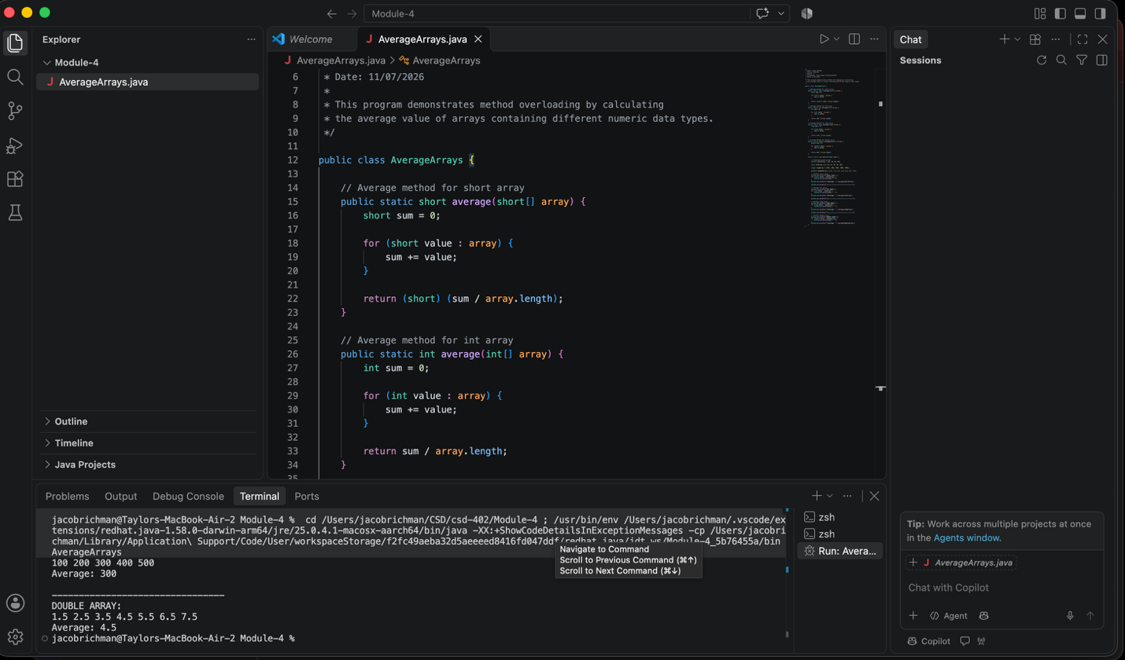
Program Description
This program demonstrates the use of method overloading in Java by creating four methods named average () that calculate the average value of arrays containing different data types, including short, int, long, and double. Although each method has the same name, Java can determine which method to execute based on the type of array passed to it. Each method uses a loop to add all values in the array, calculates the average by dividing the total sum by the number of elements in the array, and then returns the result. The program also creates arrays of different sizes to demonstrate that the methods work correctly regardless of the number of elements. Finally, the original array contents and the calculated averages are displayed in a clear and organized format, allowing the user to verify the results. This assignment illustrates important programming concepts such as arrays, loops, methods, return values, and method overloading.

